Name :SK.Kashifa

Register no :192121135

Experiment 1 :Online shopping

Class diagram :

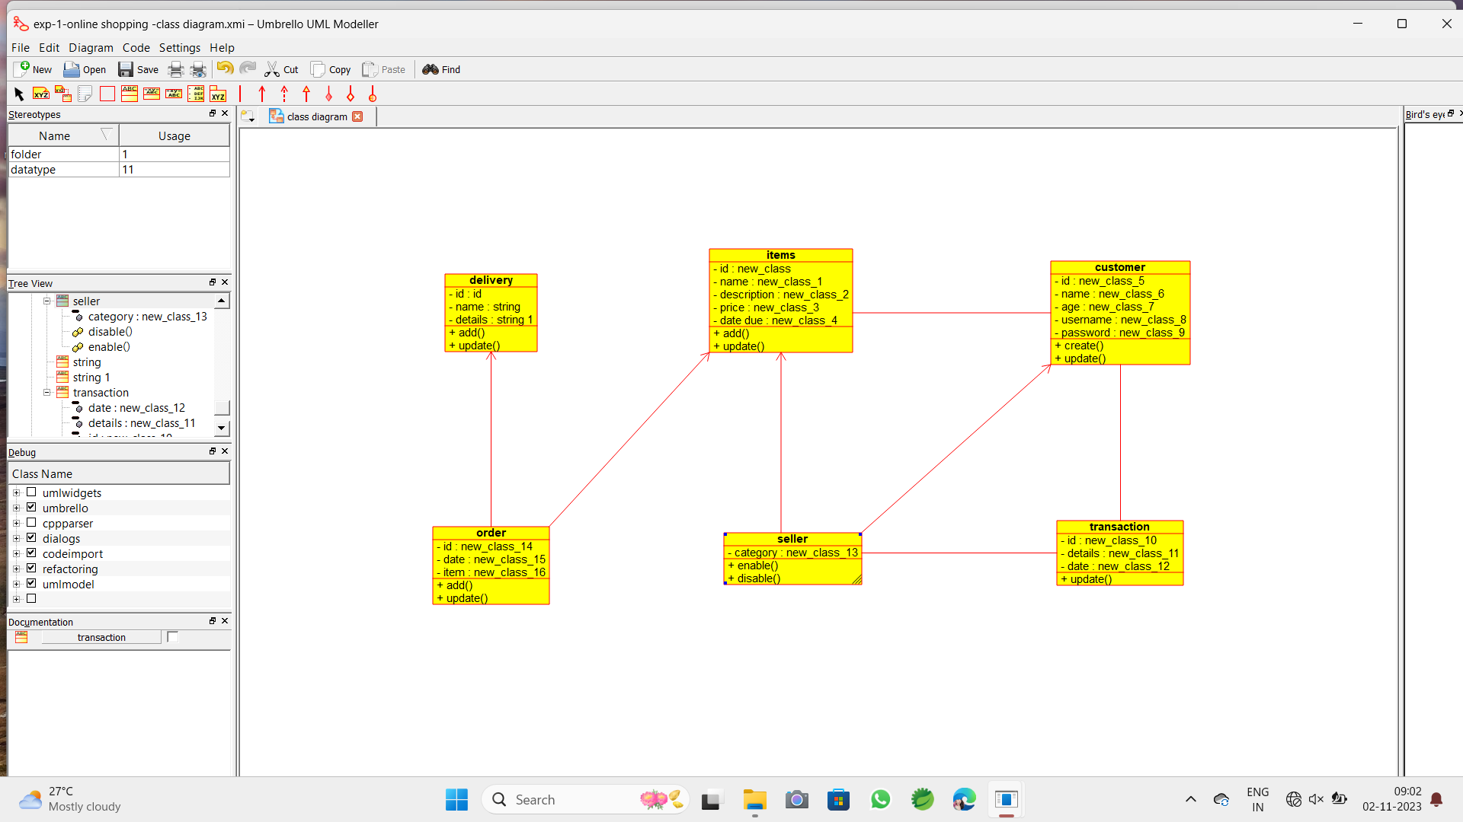

Usecase diagram :

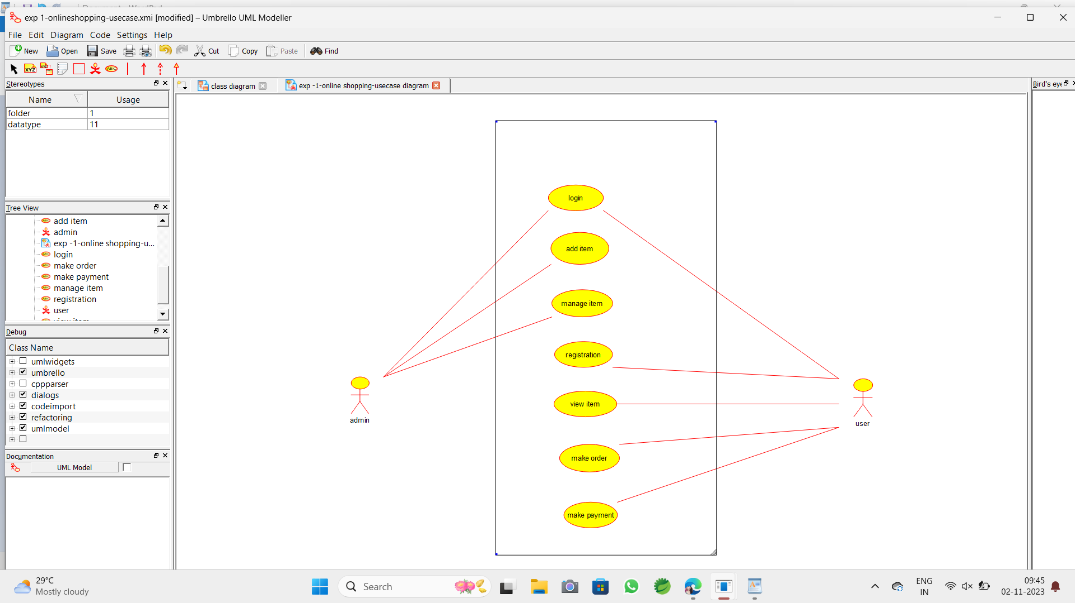

Sequence diagram :

